New Mastering Science
For Students
Student’s Book 3C
Corrigendum

★ Updated in September 2019
Page | Original text | Amendments
5 | (1st paragraph under ‘2 Light beams and light rays’)  We use a straight line and an arrow to represent the path and direction of light. This line with an arrow is called a light ray* (Fig 14.5). | Revise the wordings  We use a straight line and an arrow to represent a light ray*. It shows the path and direction of light (Fig 14.5).
8 | (2nd point in summary box)  A light ray is a straight line with an arrow. It represents the path and direction of light. | Revise the wordings  A light ray is represented by a straight line with an arrow. It shows the path and direction of light.
9 | (First 3 rows of Table 14.1)  Incident ray The light ray hitting the surface  Reflected ray The light ray leaving the surface  Normal An imaginary line perpendicular to the surface | Revise the wordings  Incident ray The light ray hitting the reflecting surface  Reflected ray The light ray leaving the reflecting surface  Normal An imaginary line perpendicular to the reflecting surface
15 | (Instructions of Activity 14.2)  Put a plane mirror in front of the following figures. Draw the images formed. | Revise the wordings and add a photo  Hold this page in front of a plane mirror as shown. Draw the shapes of the images formed.  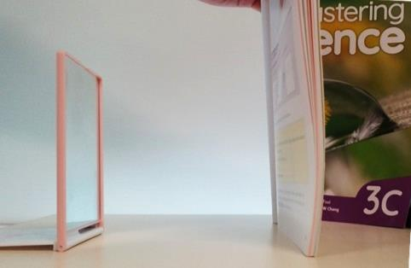  plane mirror
92 | (Website in ‘Go for more’)  http://www.bbc.co.uk/schools/gcsebitesize/science/aqa_pre_2011/radiation/the_electromagnetic_spectrumrev1.shtml  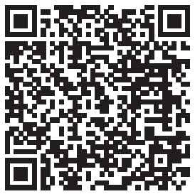 | Revise the website  https://www.bbc.co.uk/bitesize/guides/z32f4qt/revision/2  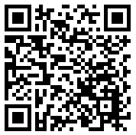
95 | (Key terms)  31 princial focus 主焦點 | Correct the spelling  31 principal focus 主焦點

