New Mastering Science
For Students
Student’s Book 2B
Corrigendum

★ Updated in October 2018
Page | Original text | Amendments
74 | (Figure that shows the process of how we see) | Redraw light rays entering the eye to cover the whole pupil
133 | (Photo of step 1) | Replace the photo (cutting with a pair of kitchen scissors)  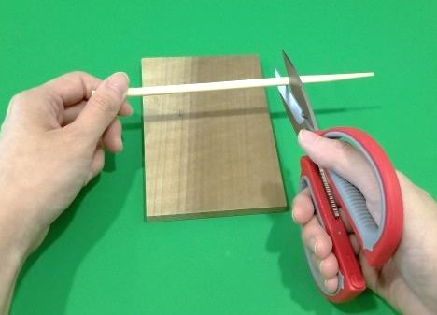  Be careful!
136 | (Diagram of point 5) | Rewrite step 2  The cornea and the lens bend the light and focus it on the retina. An inverted image is formed on the retina.  Redraw the light rays entering the eye
156 | (Label in the Fig 11.6)  She applies a force to press the flour | Revise wordings  She applies a force to knead the dough

