New Mastering Science
For Students
Student’s Book 1A
Corrigendum

★ Updated in September 2019
Page | Original text | Amendments
76 | (x-axis in the graph of Practical 2.1)  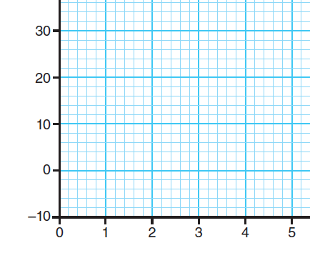 | The position of the x-axis is moved upwards  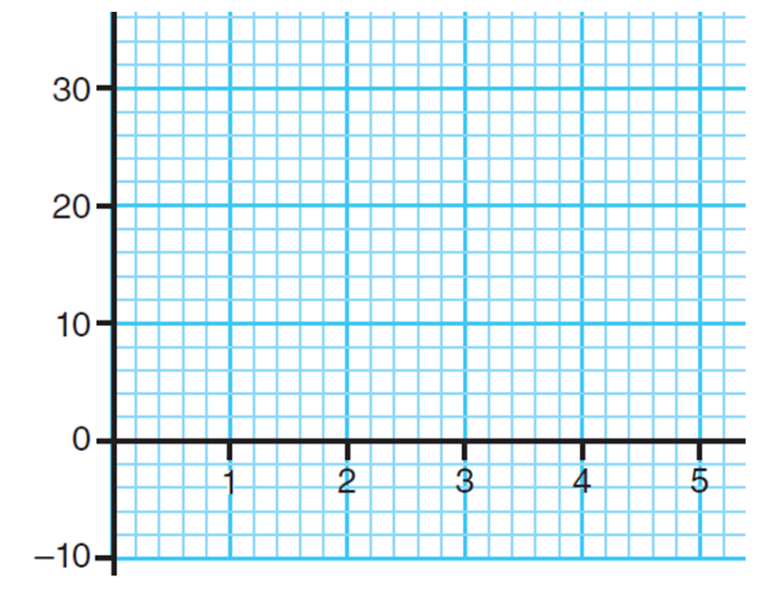
102 | (The apparatus and material list in Practical 2.8)  Apparatus and materials per group  Measuring cylinder (100 cm³) 1°  ... | Delete the ‘°’ in the list  Apparatus and materials per group  Measuring cylinder (100 cm³) 1  ...
155 | (Question 1c of ‘Checkpoint 1’)  Photosynthesis is one of the vital functions of living things. | Revise the wording  Photosynthesis is one of the vital functions of all living things.
170 | (Useful app) | The app is no longer available.

